Bootstrap

Technical Training Outline

Andrew Ray

10/1/2018

Table of contents

1 Introduction 3

2 Goals and Benefits 3

3 Prerequisites 4

4 Course Outline 4

5 Member’s Responsibilities 6

5.1.1 Bootstrap Grid System for Organizing Content 6

5.1.2 Bootstrap Table 6

5.1.3 Support Two Viewports 6

5.1.4 Six Bootstrap Components 7

5.1.5 Five Bootstrap Utilities 7

5.1.6 One Media Objects 7

5.1.7 CSS Preprocessing 8

6 Reviewer’s Responsibilities 8

7 Schedule Time Line 8

8 References 9

# Introduction

*g. Describe objects and give a quick overview of the material.}*

Upon completion of this course, an engineer should be able to demonstrate a basic core level of competence in the technology.

# Goals and Benefits

The goal of this course is to provide members with an understanding of the fundamentals of CSS and the value provided by a CSS framework. Through the completion of this course, members will develop a solid understanding of the Bootstrap framework. Completing the course and attaining endorsement from the reviewer will aid in CGI’s resource management and allocation, as management will have a more quantifiable way of measuring member’s skill levels.

The benefits of receiving the *Technical Training - Bootstrap* course endorsement from the reviewer to the member include:

* Expansion of technical knowledge
* Recognition within the organization

The benefits of receiving the *Technical Training - Bootstrap* course endorsement from the reviewer to CGI include:

* Fundamental architecture knowledge of across the consulting pool
* Accurate evaluation of skills across the consulting pool
* An increased culture of information sharing and peer accountability in the consulting pool

# Prerequisites

* Knowledge of HTML5 fundamentals

# Course Outline

| Class | Description | Topics |
| --- | --- | --- |
| Class 1 | Introduction to CSS | * Including Stylesheets * CSS Refresher * Bundling, Minification, and CDNs |
| Class 2 | Introduction to Bootstrap | * Responsive Layout * Columns * Alignment * Ordering * Nesting |
| Class 3 | Content | * Typography * Images * Tables * Figures |
| Class 4 | Components | * Alerts * Badge * Buttons * Card * Carousel * Collapse * Dropdown |
| Class 5 | Components cont. | * Forms * Input Group * Modal * Navs * Navbar * Pagination * Popovers * Progress * Scrollspy * Tooltips |
| Class 6 | Utilities | * Border * Clearfix * Colors * Display * Embed * Flex * Float |
| Class 7 | Utilities cont. | * Position * Screen Readers * Sizing * Spacing * Text * Vertical Align * Visibility |
| Class 8 | CSS Preprocessing | * Mixins * Variables * Extends * Rule Nesting * Operators * Directives |

# Member’s Responsibilities

A member will be required to demonstrate knowledge of all items identified in the Course Outline section of this document above. Additionally, the member must also complete the following assignment:

Create a web page that includes the following criteria:

### Bootstrap Grid System for Organizing Content

### Bootstrap Table

* Table must have separate header and body Bootstrap styles
* Table must contain highlighted cells
* Table must be responsive

**Example:**

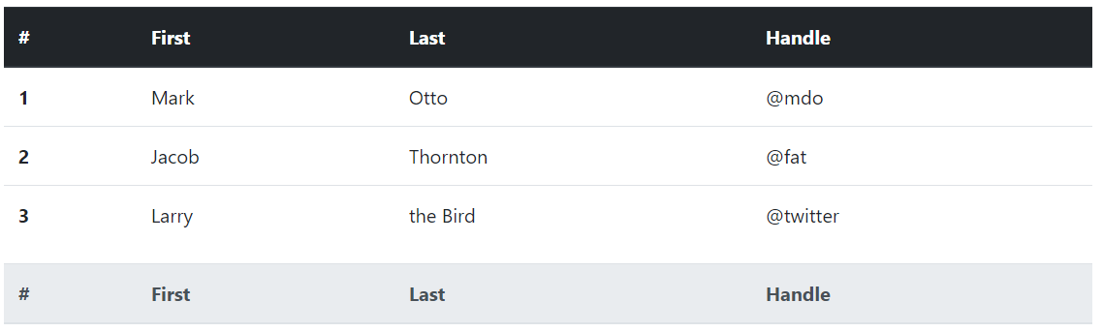

### Support Two Viewports

* The content of your web page must change its orientation between two viewports of the member’s choosing

### Six Bootstrap Components

Four of the components are specified below. The other two components can be of the members choosing.

**Component 1:** Nav with tabs or pills

**Example:**



**Component 2:** Navbar

**Example:**



### Five Bootstrap Utilities

Three of the utilities are specified below. The others can can be of the member’s choosing.

**Utility 1:** Color

**Utility 2:** Spacing

**Utility 3:** Flex

### One Media Object

Include at least one image or figure. The image or figure must be responsive.

### CSS Preprocessing

Include one of each of the following:

* Mixin
* Variable
* Extends
* Directives
* Rule Nesting

The intent is that the created solution does not necessarily have to contain or demonstrate all of the elements detailed in the Course Outline section. However, at demonstration time, the member must definitively demonstrate detailed knowledge of how to implement each skill.

# Reviewer’s Responsibilities

The reviewer is responsible for certifying the member as having completed this training. The reviewer must perform the following steps in the process:

* Review completed assignment with member
* Assess knowledge of all core skills identified in the Course Outline section
* Provide notification of course completion to the Member Relations Coordinator

# Schedule Time Line

The following timeline is recommended for the core competency process:

|  |  |
| --- | --- |
| Task | Timeline |
| Complete review of all items within the Course Outline section | *8 Days* |
| Complete development of assignment | *2 Days* |

# References

Further references on can be found at the following locations:

Note: Some of the below refer to Bootstrap 3 tutorials. No breaking changes were introduced in Bootstrap 4 and all of these tutorials are still valid.

* [Bootstrap Introduction - Skillport](https://cgi.skillport.com/skillportfe/main.action?path=summary/COURSES/sl_btsp_a01_it_enus)
* [Bootstrap Elements - Skillport](https://cgi.skillport.com/skillportfe/main.action?path=summary/COURSES/sl_btsp_a02_it_enus)
* [Bootstrap 4 for the Developer - Pluralsight](https://www.pluralsight.com/courses/bootstrap-4-developer)
* [Bootstrap 3 - Pluralsight](https://www.pluralsight.com/courses/bootstrap-3)
* [Responsive Websites With Bootstrap 3 - Pluralsight](https://www.pluralsight.com/courses/responsive-websites-bootstrap3)